Activity and State Diagrams

Tenant
FR1- Update personal information.
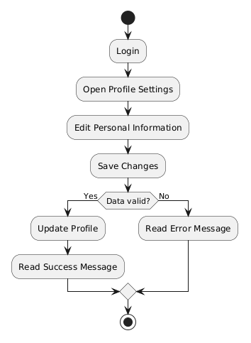

FR2 - Search properties based on their preferences.
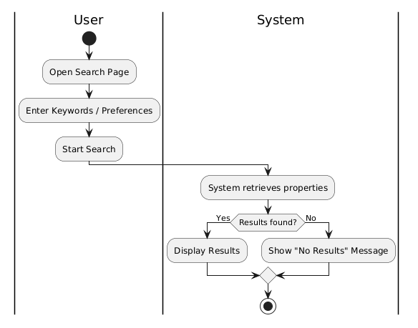

FR3 - Filter properties by location,price and property type.

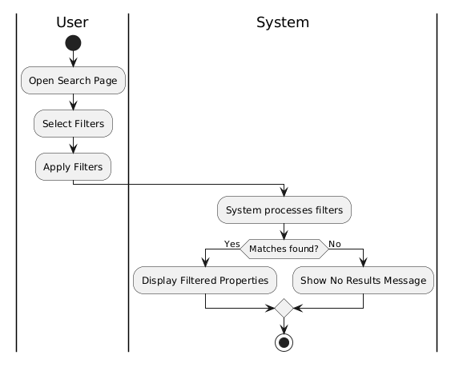

FR4 - View property details and booking history.

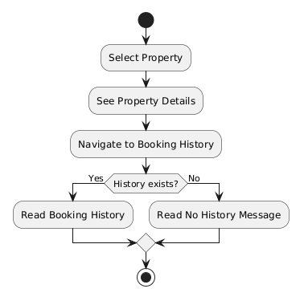

FR5 - Send rental requests and message to property owners.
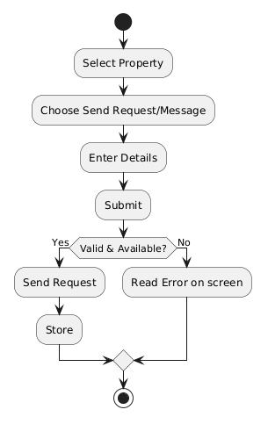

FR6 - Cancel request status.
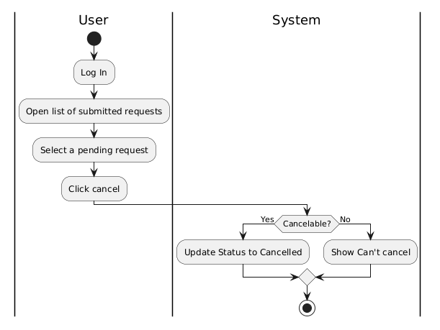
FR7 - Receive messages from property owners.
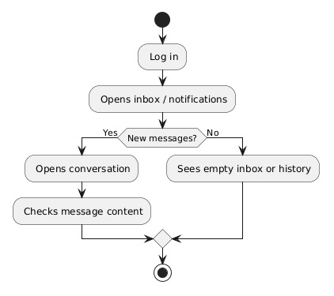

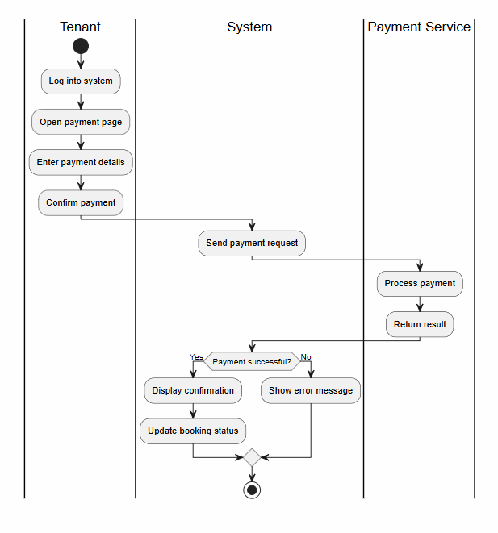
FR8 – Submit rental payments.

FR9 - Save favourite properties for later viewing.
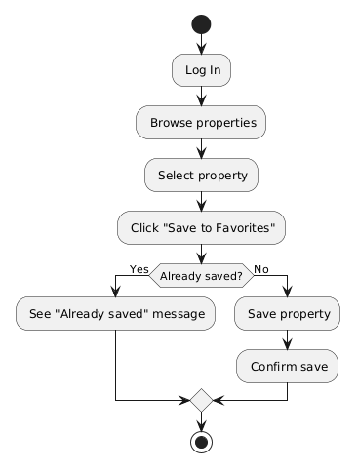

FR10 – Review and Rate property
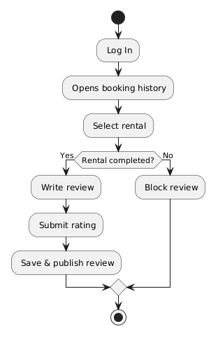

Property Owner

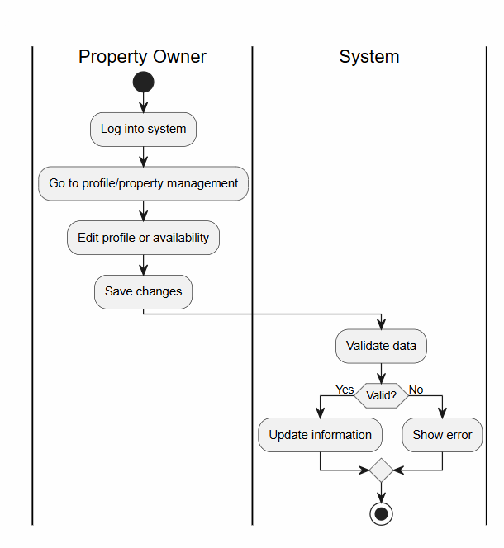
FR11 - Update Profile Information and availability of rental properties

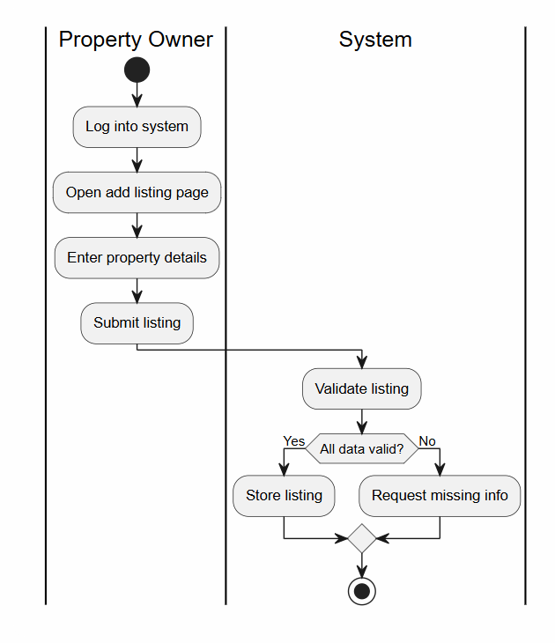
FR12 - Add Property Listing

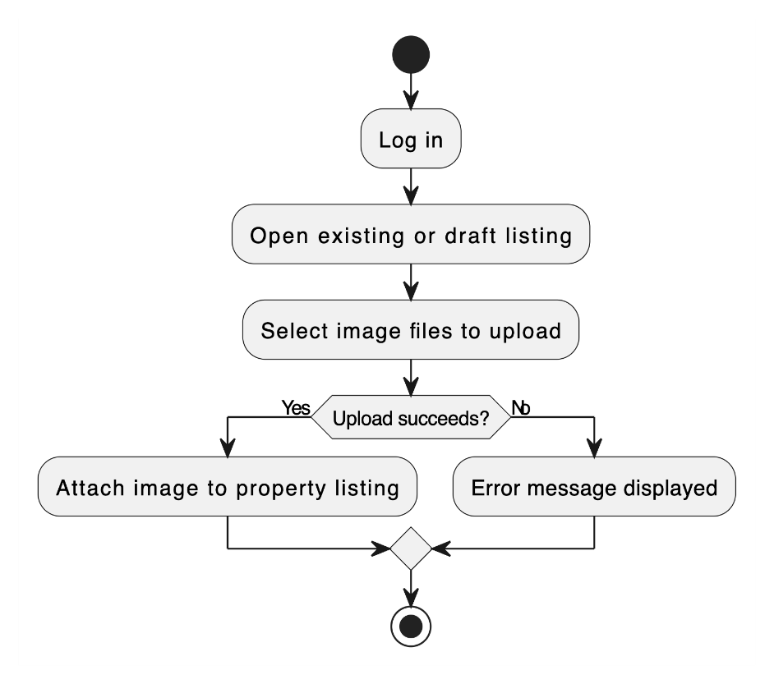
FR13 - Upload Property Images

FR14 - Edit Property Listing
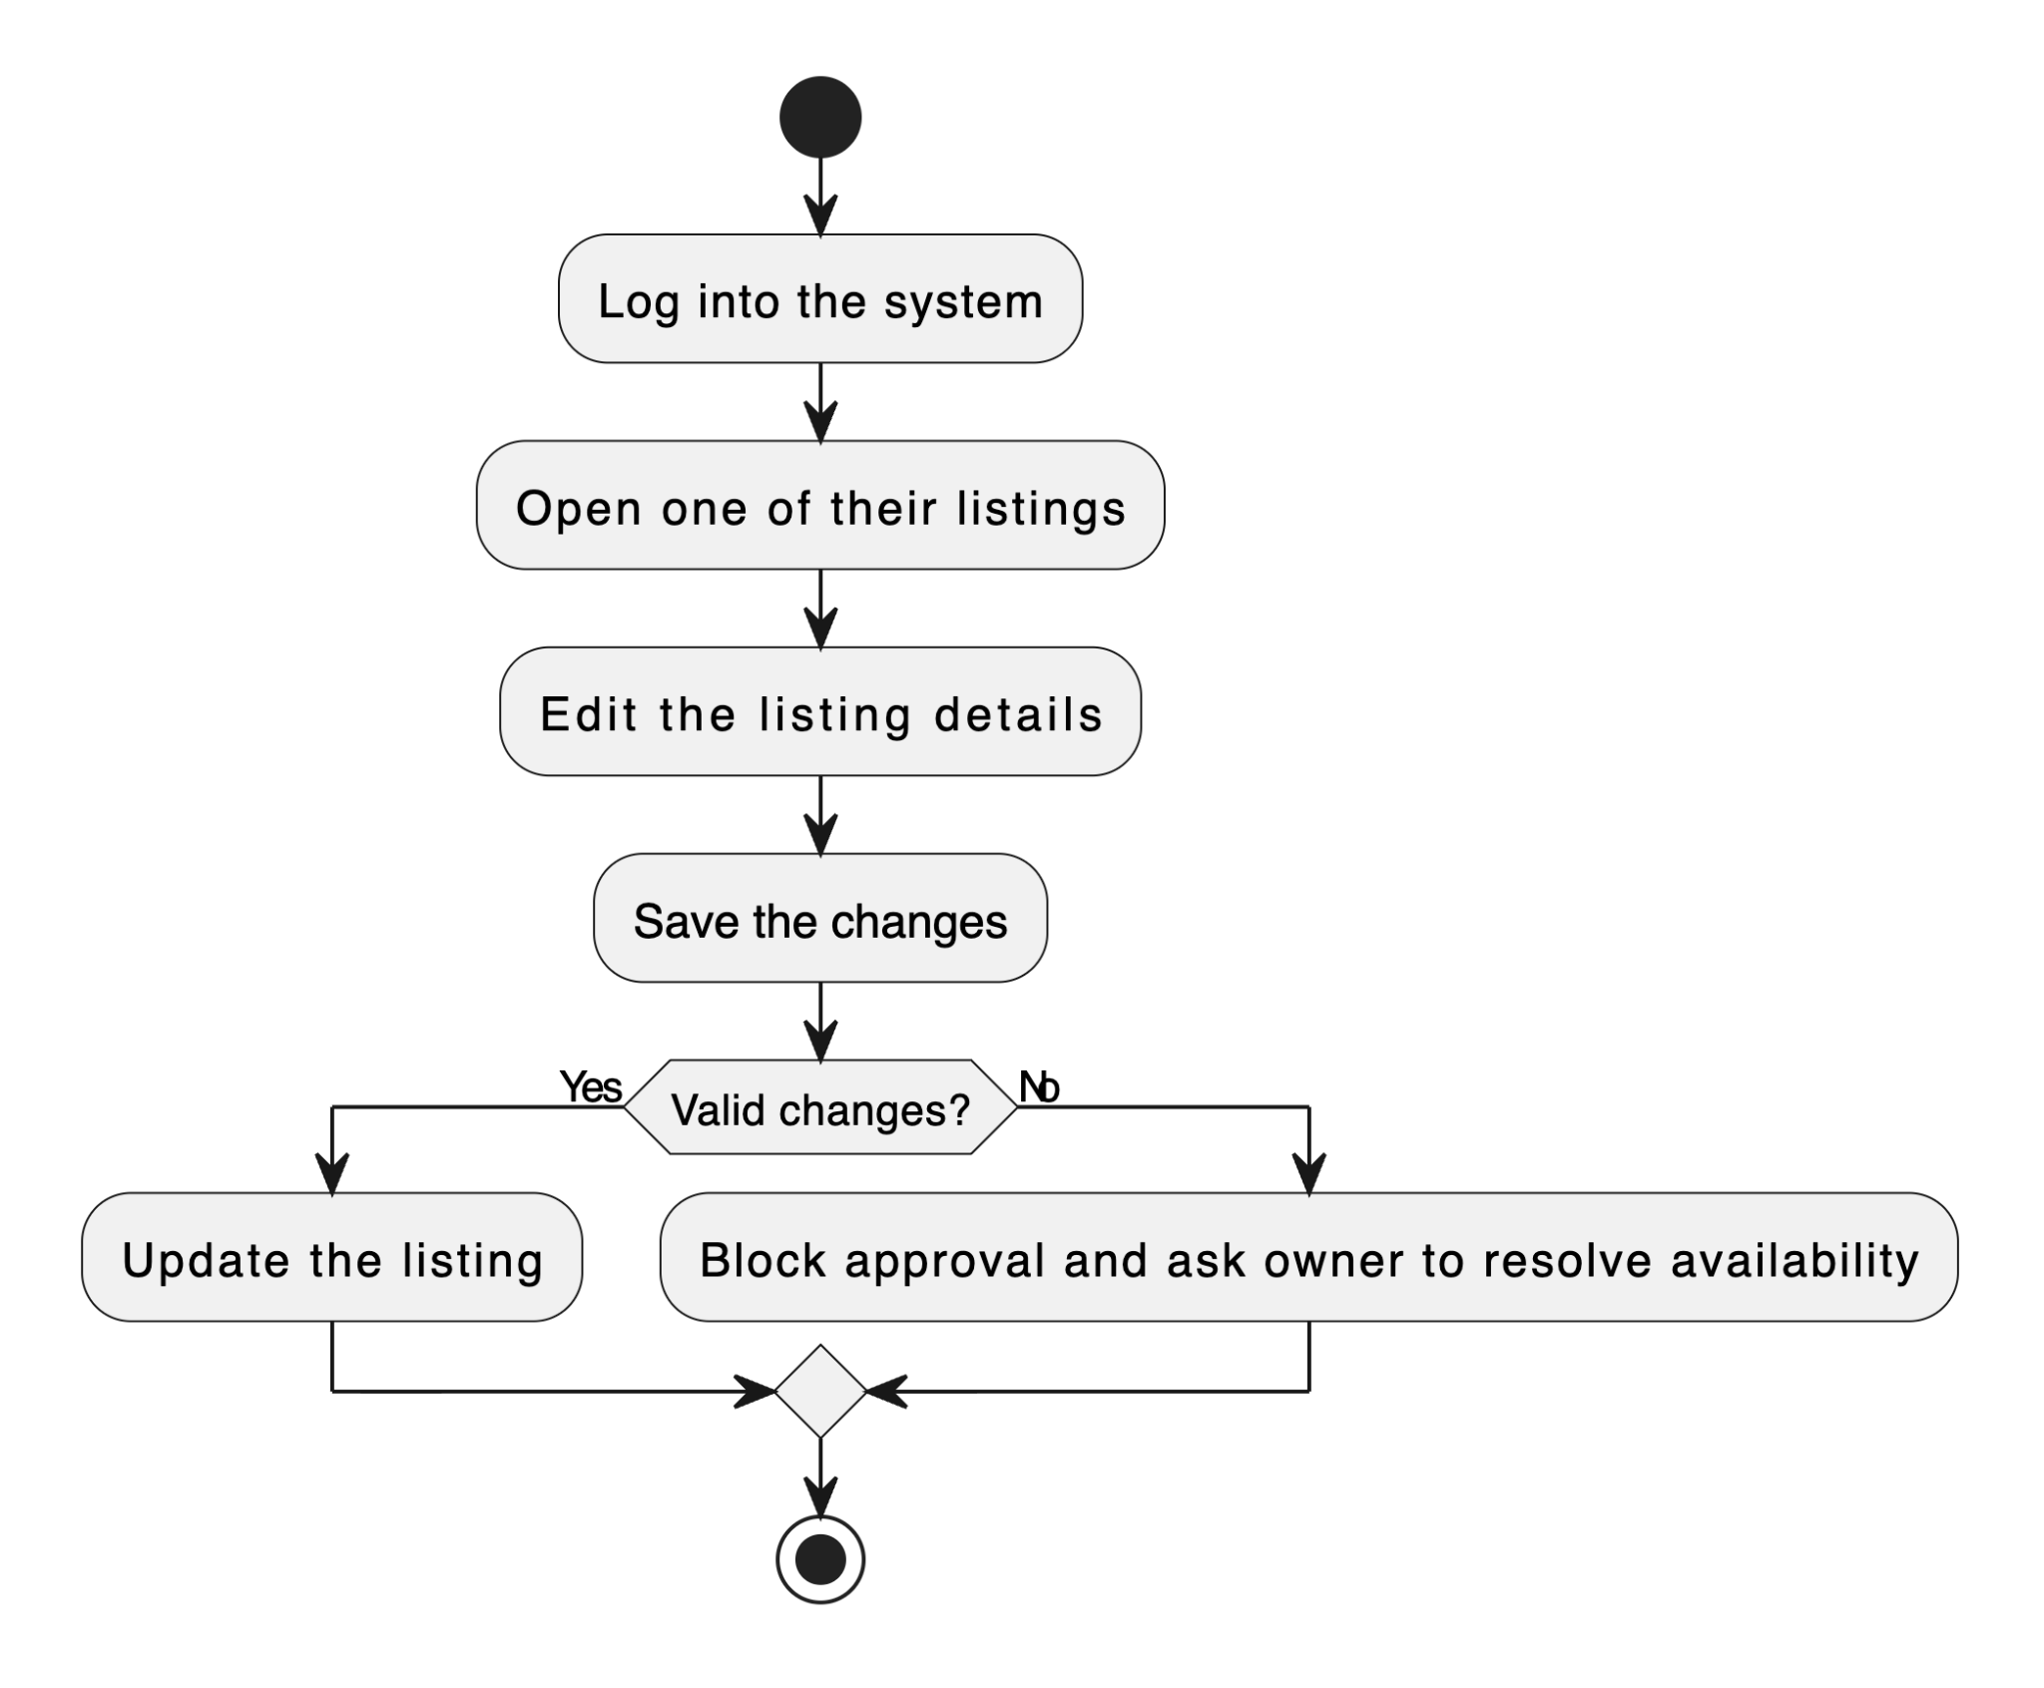

FR15 - Delete Property Listing
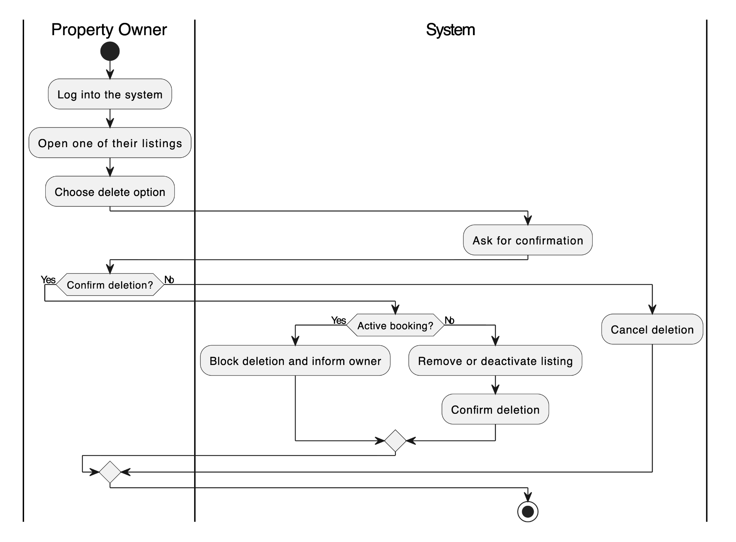

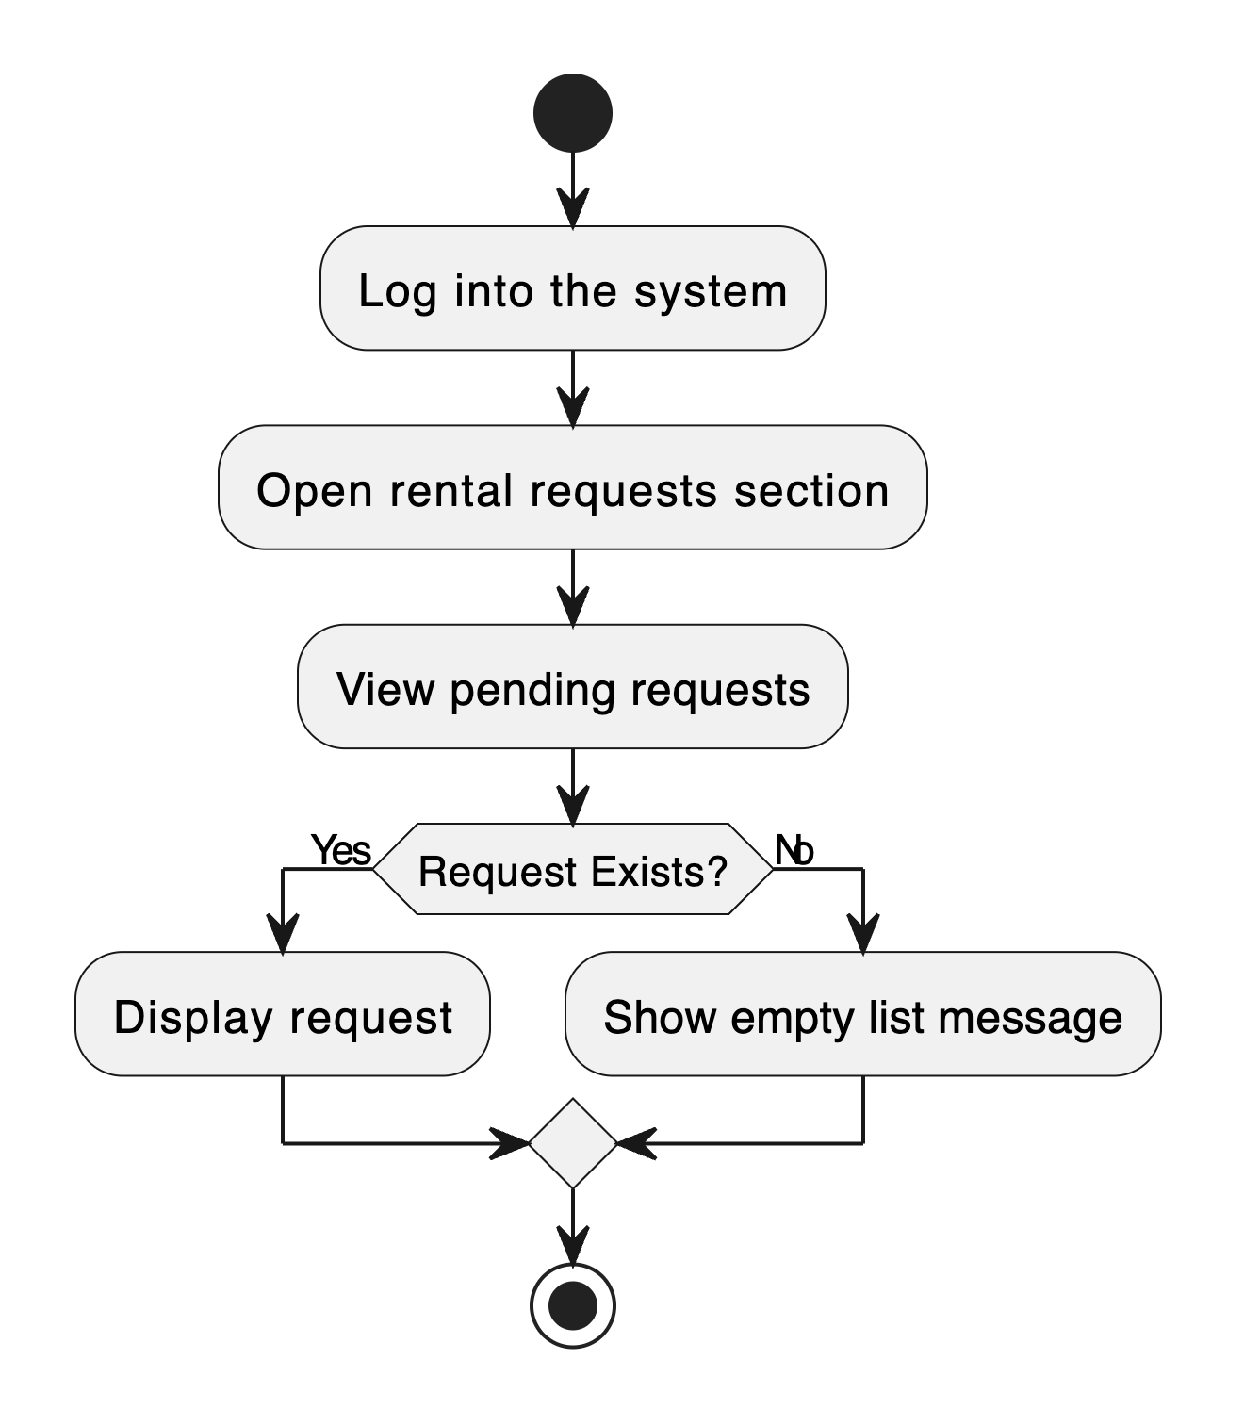
FR16 - View Rental Requests

FR17 - Accept or Reject Rental Request

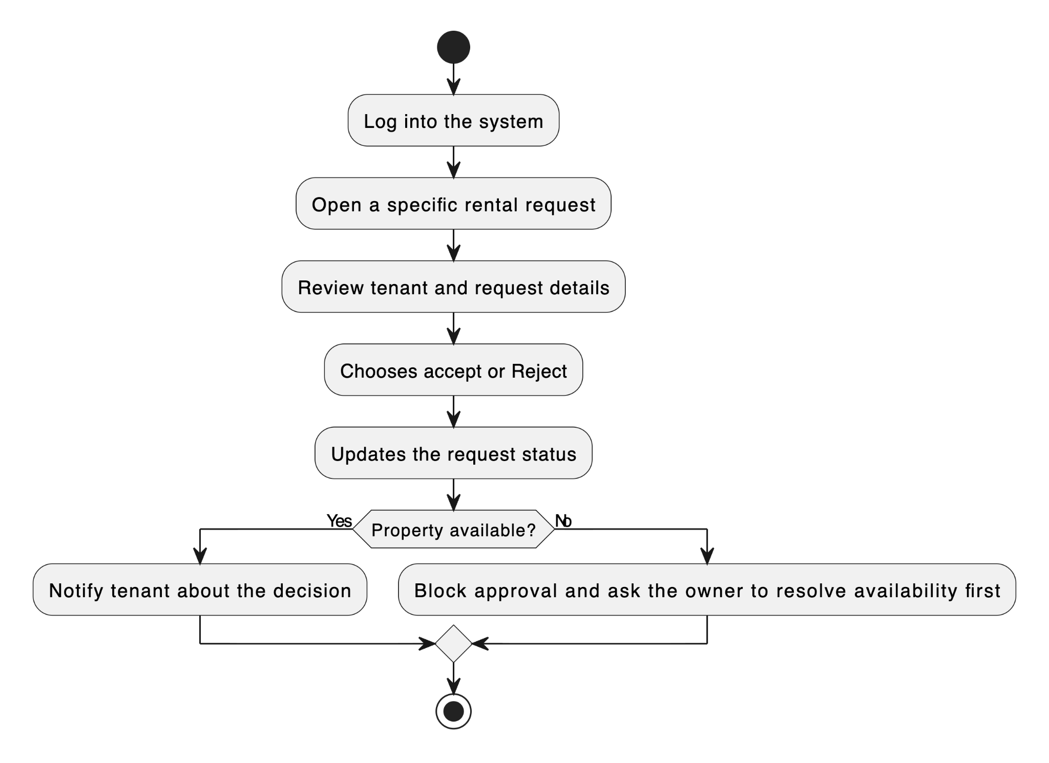

FR18 - Send Message to Tenant
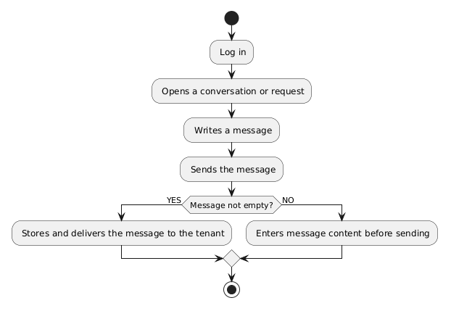

FR19 - View Booking History
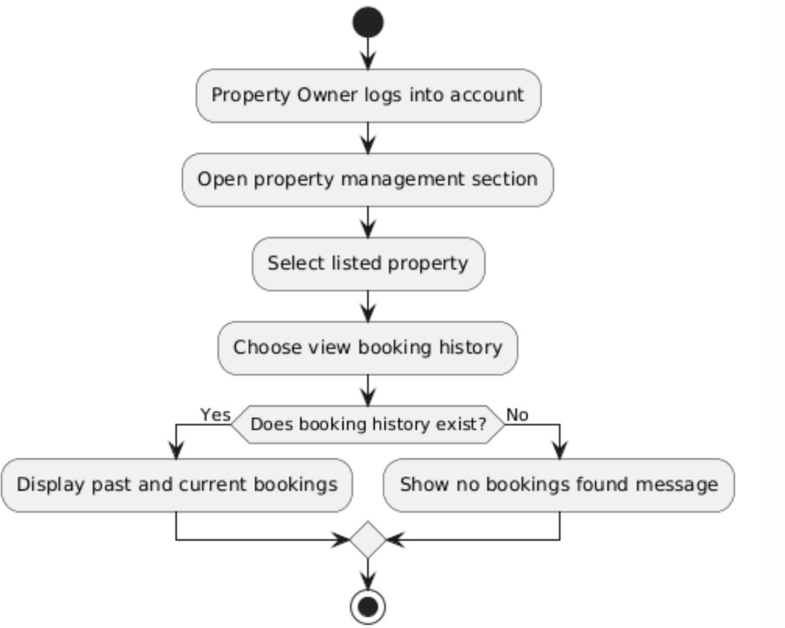

FR20 - Mark Property as Unavailable or Rented
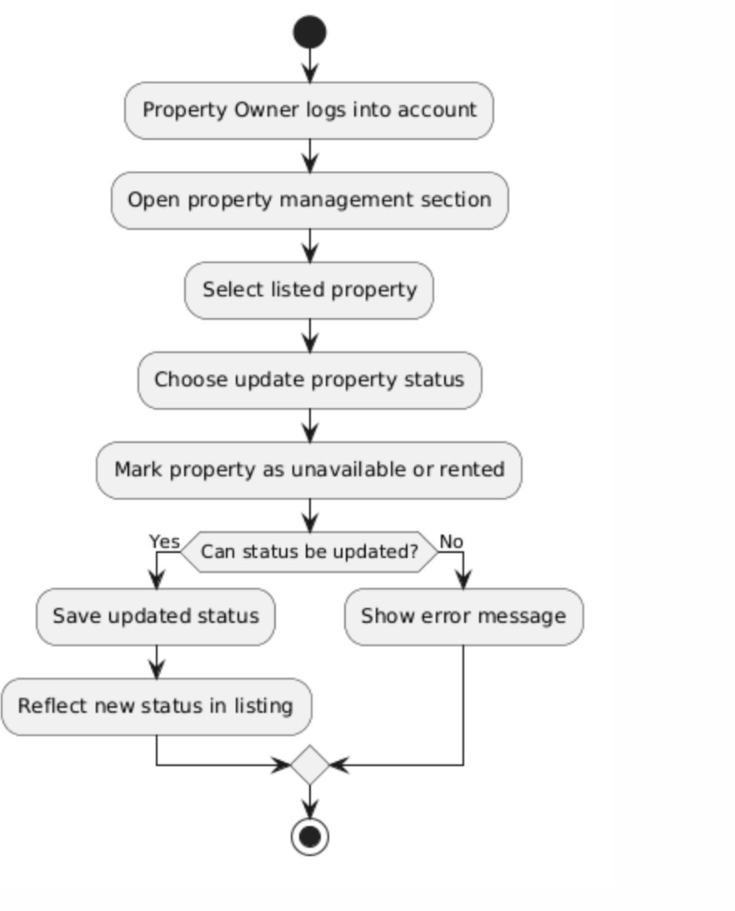
Administrator
FR21 - Edit User Accounts
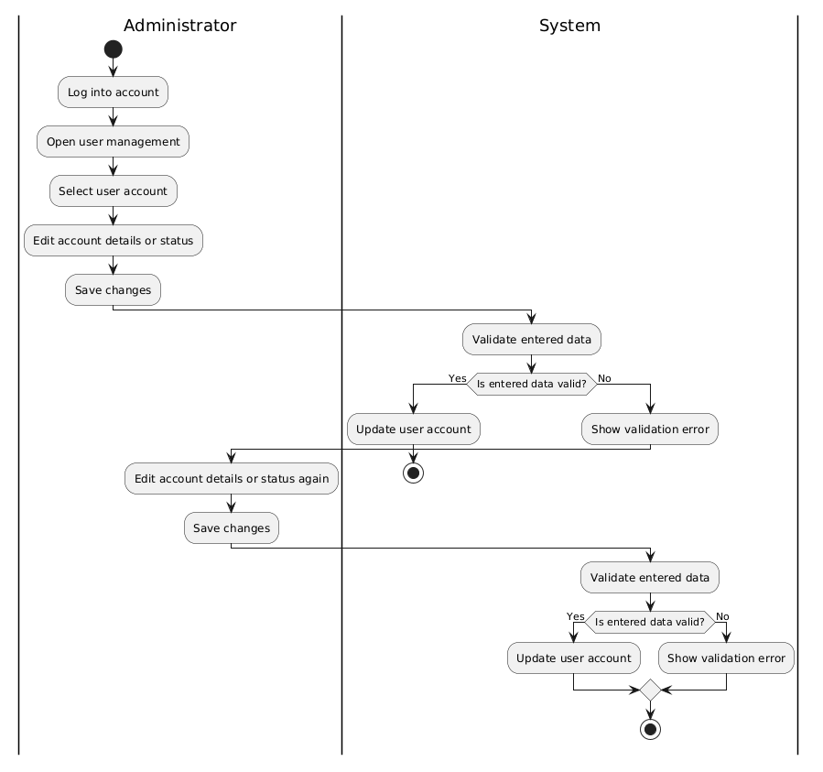

FR22 - Delete User Accounts
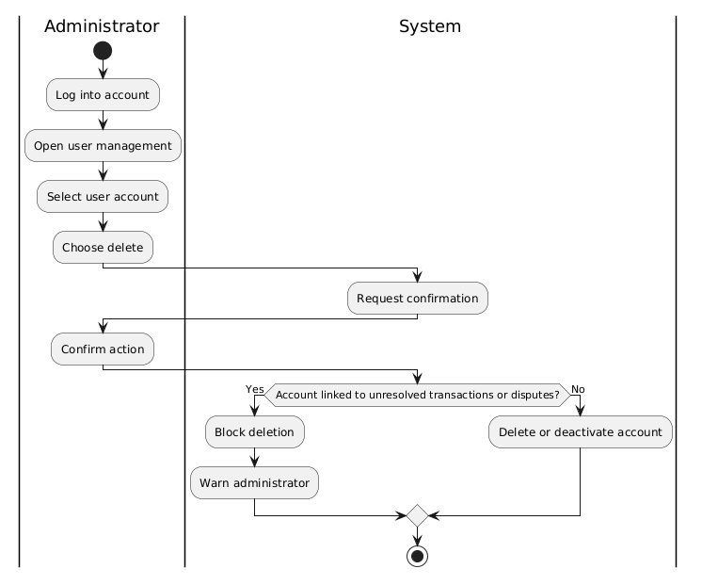

FR23 - Monitor Rental Transactions
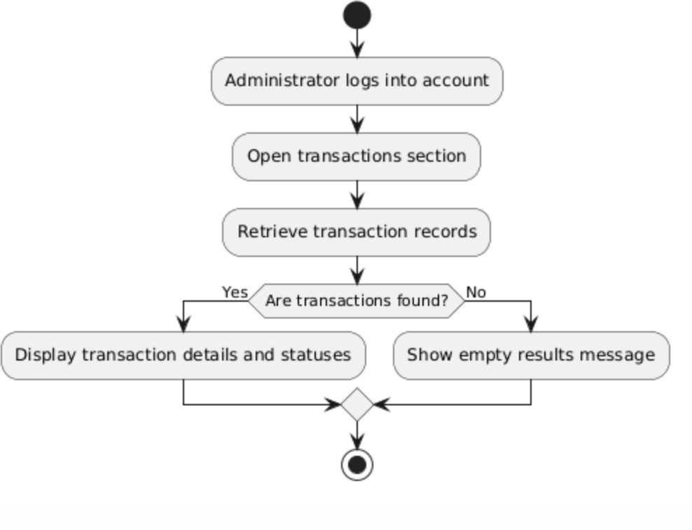

FR24 - View System Reports and Property Listings
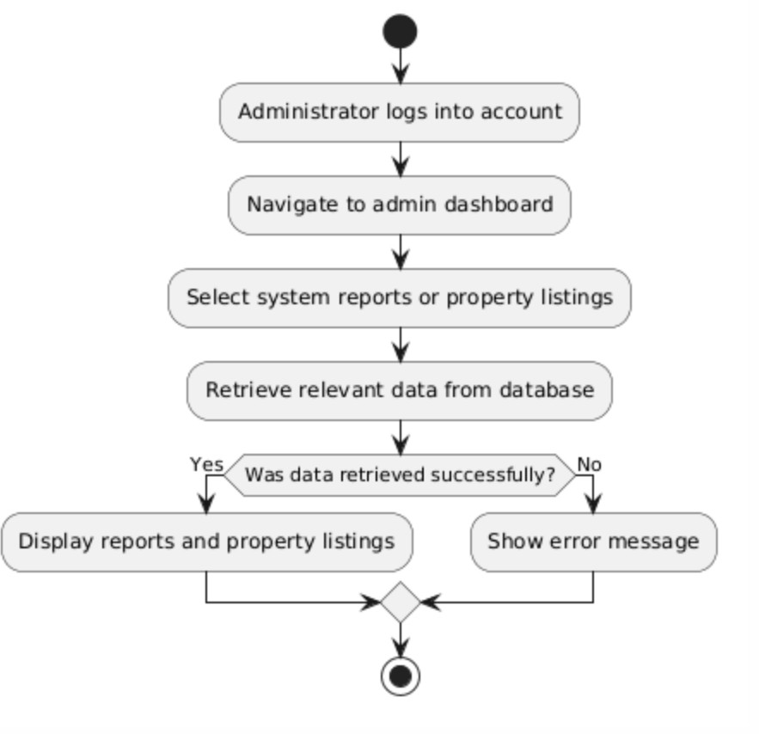

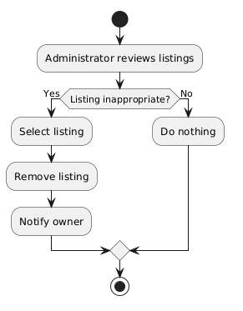
FR25 - Remove Inappropriate Listings

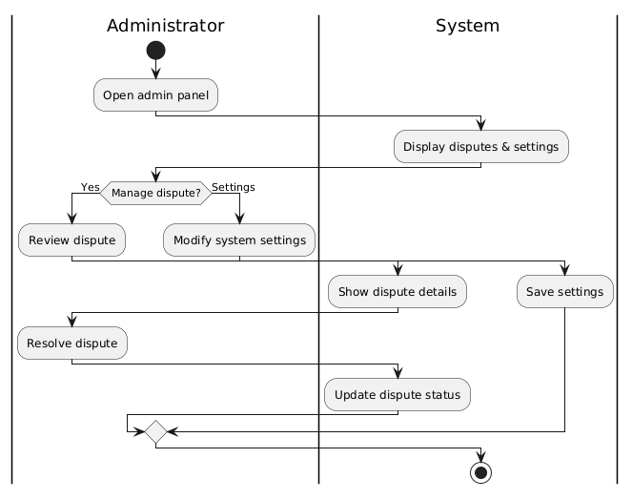
FR26 - Manage Disputes and System Settings

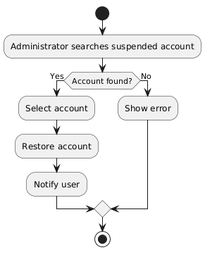
FR27 - Restore User Accounts

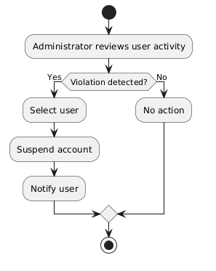
FR28 - Suspend User Accounts

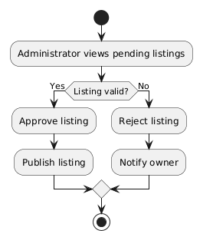
FR29 - Verify and Approve property listings

Manager

FR30 - Monitor Rental Requests
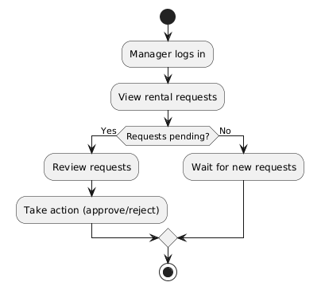

FR31 - Generate Management Reports
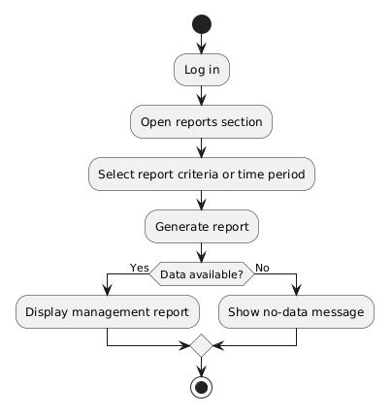

FR32 - Approve Large Discounts and Promotions
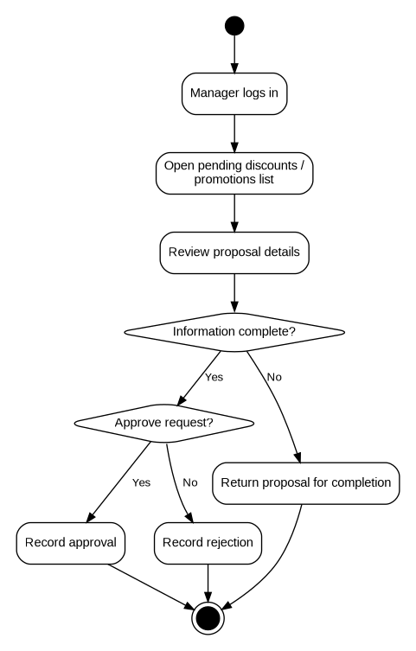

FR33 - Review Complaints and Forward Unresolved Issues
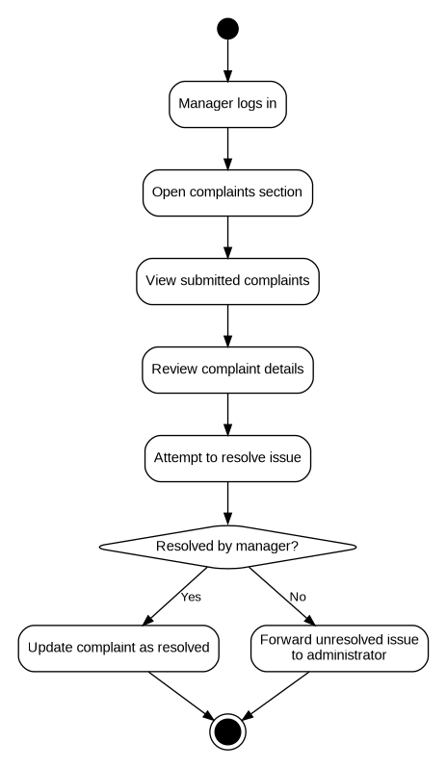

Financier

FR34 - View Transaction History

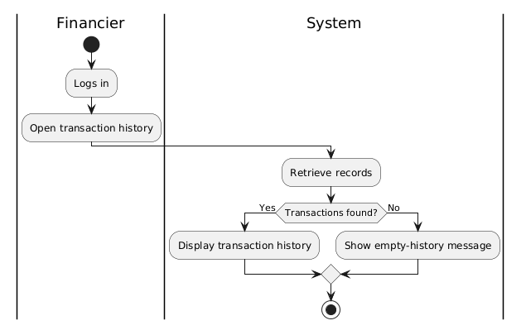

FR35 - Monitor Payment Process and Security

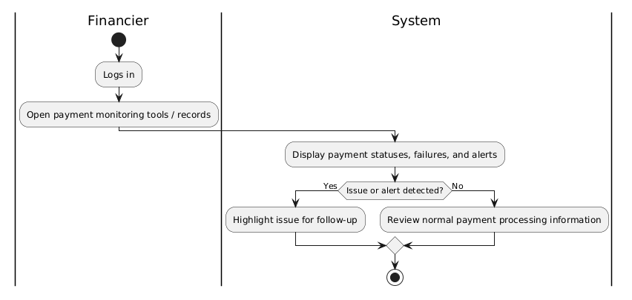

FR36 - Communicate Payment Issues with Tenants and Owners
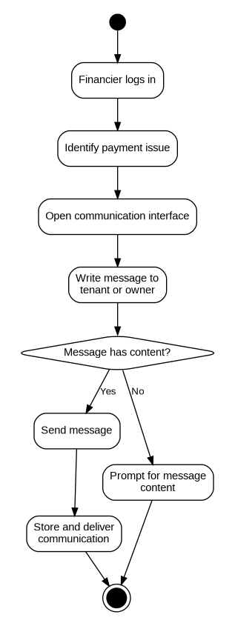

FR37 - Approve Refunds for cancelled Rental Transactions

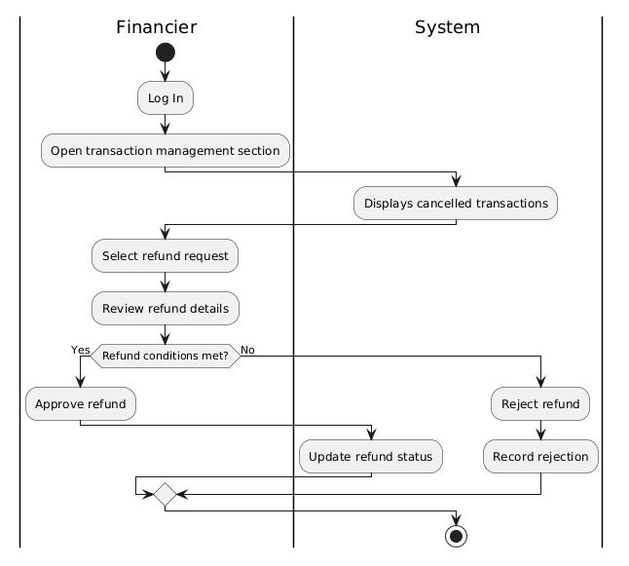

Human Resources (HR)

FR38 - Manage Complaints
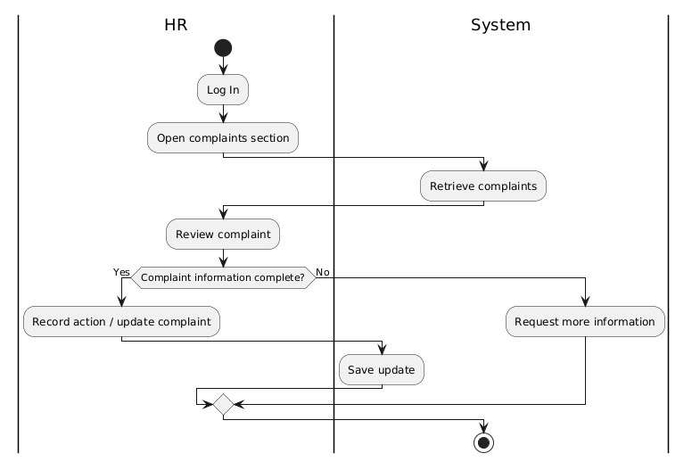

FR39 - Send Notifications and Reminders

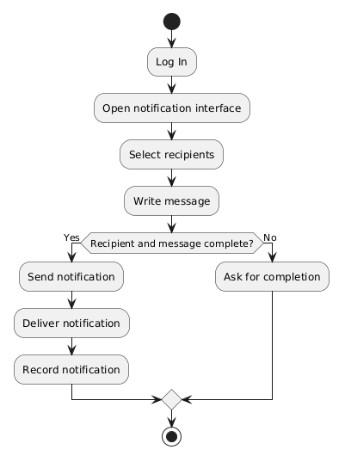

FR40 - Maintain Records of User Issues and Resolutions
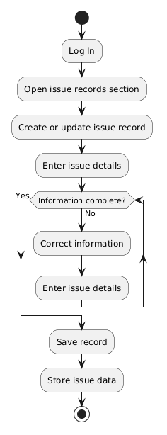

User (these 2 processes are the same for all 6 actors. All actors inherit from UCT of user)

FR41 - Register Account
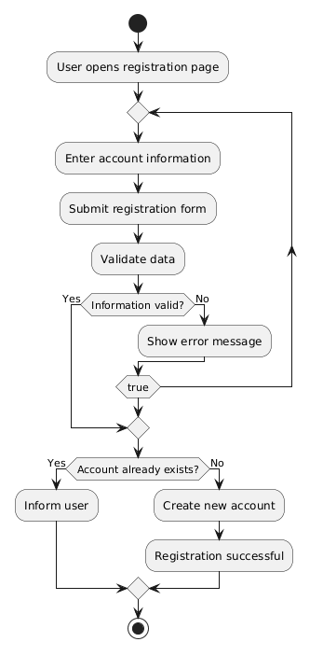

FR42 - Log In
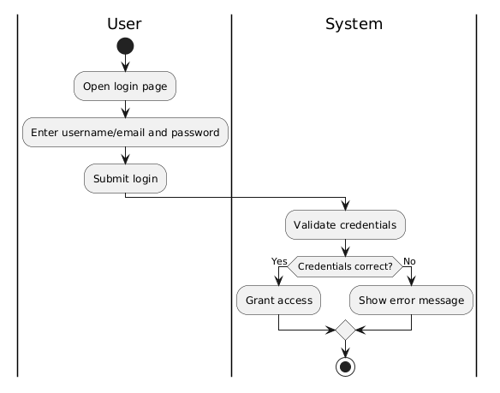

FR43 – Log Out
